**EDA for the data "*takehome_user_engagement*"**

This is the short summary from the findings of exploratory analysis of the following data "takehome_user_engagement.csv”.

1. **Top contributors** – We can see that there was significant amount of new users were referred/invited by existing users and the histogram below shows the spread of the counts. Some of top contributors - ***10741.0, 2527.0,1525.0,11770.0,2308.0,8068.0 7012.0,6370.0,4803.0,2354.0,10481.0,10628.0,4302.0,1175.0,4612.0***.
2. **Creation source (propotions)** – From the data that presented to us, most of the account creation source is falls under ORG_INVITE category. Which is significantly higher (35%) than rest of the categories (GUEST_INVITE , PERSONAL_PROJECTS, SIGNUP).

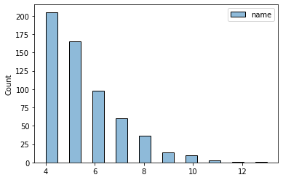 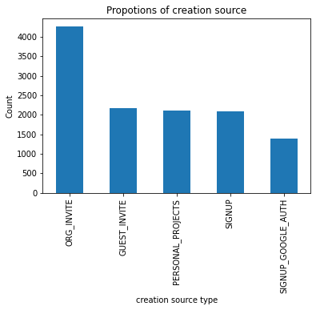

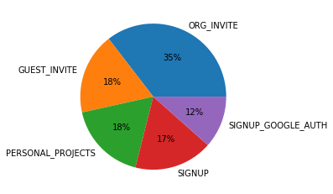

The above piechart shows the percentage of propotions for creation source.

1. Correlations- From the below heatmap we can see that the “opted_to_mailing_list” and “enabled_for_marketing_dip” have some direct correlation, other parameters are not significantly correlated which we can see from the pairplot below.

